Business Sales Performance Analytics Report
Data Science & Analytics – Task 1 (2026)
By Future Interns
Prepared By: Pushp Jain

1. Project Overview
This project focuses on analysing business sales data to understand revenue trends, product performance, regional profitability, and category-wise business growth.
The objective of this analysis is to identify important business patterns and generate actionable insights that can help improve profitability, sales performance, and business decision-making.
Using sales data analytics, the project aims to answer key business questions such as:
- Which products generate maximum revenue?
- How do sales change over time?
- Which regions are most profitable?
- Which product categories contribute the most profit?
- What business improvements can be suggested?
The analysis was performed using Power BI to create an interactive and professional business dashboard.

2. Tools & Technologies Used
The following tools were used to complete this project:
Tool | Purpose
Power BI | Data visualization & dashboard creation
CSV Dataset | Business sales data analysis
Microsoft Word | Documentation & reporting

3. Dataset Information
For this project, the Superstore Sales Dataset was used.
The dataset contains important business-related information including:
- Order ID
- Order Date
- Product Name
- Category
- Region
- Sales
- Profit
- Quantity Sold
- Discount
This dataset represents a retail business scenario and helps in performing real-world business analytics.

4. Data Cleaning & Preparation
Before analysis, the dataset was cleaned and prepared to ensure accurate results.
The following preprocessing steps were performed:
4.1 Handling Data Types
- Converted Order Date and Ship Date into proper date format.
- Corrected numeric columns such as:
  - Sales
  - Profit
  - Quantity
  - Discount
4.2 Removing Errors
- Fixed incorrect date format issues using locale settings.
- Removed data inconsistencies.
4.3 Data Validation
- Verified important columns for accuracy.
- Checked for missing values and formatting issues.
This process ensured the dataset was ready for meaningful business analysis.

5. Key Performance Indicators (KPIs)
The following KPIs were analysed to understand overall business performance:
Total Sales
2.30 Million
Represents total revenue generated by the business.
Total Profit
286.40 Thousand
Represents total earnings after costs.
Total Quantity Sold
38 Thousand Units
Represents total products sold.
Total Orders
5.009 Thousand Orders
Represents the total number of customer orders processed.

6. Dashboard Analysis
The dashboard was designed to analyse business performance through multiple perspectives.
6.1 Sales Trend Over Time
The sales trend chart shows fluctuations in sales over different periods.
Observation
Sales fluctuated over time but demonstrated an overall increasing trend.
Business Insight
The company experienced growth over time despite occasional fluctuations.
Recommendation
The business should identify seasonal demand patterns and optimize marketing campaigns during high-performing periods.

6.2 Category-wise Sales Analysis
The category-wise sales analysis compares revenue generated by different product categories.
Observation
The Technology category generated the highest sales, while Office Supplies and Furniture contributed comparatively lower sales.
Business Insight
Technology products play a major role in business revenue generation.
Recommendation
The company should invest more in technology products and improve marketing strategies for lower-performing categories.

6.3 Region-wise Profit Analysis
Regional analysis was conducted to identify profitable business regions.
Observation
The West region generated the highest profit, while the Central region generated the lowest profit.
Business Insight
Regional performance varies significantly across the business.
Recommendation
The company should study successful business strategies in the West region and apply improvements to underperforming regions like Central.

6.4 Category-wise Profit Analysis
Profitability analysis helps understand which category contributes the most earnings.
Observation
The Technology category generated the highest profit, whereas Furniture generated the lowest profit.
Business Insight
Higher sales do not always lead to higher profitability.
Recommendation
The business should review pricing, discounting, and operational costs in the Furniture category.

6.5 Top 10 Products Analysis
The top-performing products were identified based on total sales.
Observation
A limited number of products contributed significantly to total revenue.
Business Insight
Certain products act as major revenue drivers for the business.
Recommendation
The company should prioritize inventory management and marketing for high-performing products.

7. Key Findings
Based on the analysis, the following findings were identified:
- Technology is the highest-performing category in terms of both sales and profit.
- The West region is the most profitable business region.
- Furniture category requires improvement due to lower profitability.
- Sales fluctuate over time but show overall business growth.
- A small number of products contribute significantly to business revenue.

8. Business Recommendations
Based on the findings, the following recommendations are suggested:
1. Increase Investment in Technology Products
Technology products are the strongest contributors to business growth and profitability.
2. Improve Central Region Performance
Investigate customer behaviour, operational efficiency, and marketing strategy in low-performing regions.
3. Review Furniture Category Strategy
Optimize discount strategies and pricing models to improve furniture profitability.
4. Focus on Top-selling Products
Maintain stock availability and increase promotions for top-performing products.
5. Use Seasonal Trend Analysis
Identify high-sales periods and optimize campaigns accordingly.

9. Conclusion
This project successfully analysed business sales performance using data analytics and visualization techniques.
Through KPI analysis, category analysis, regional performance evaluation, and product trend analysis, valuable business insights were generated.
The dashboard helps stakeholders understand business performance and supports better decision-making through data-driven recommendations.
Overall, this project demonstrates how business analytics can be used to improve revenue, profitability, and operational strategy.

10. Dashboard Screenshot
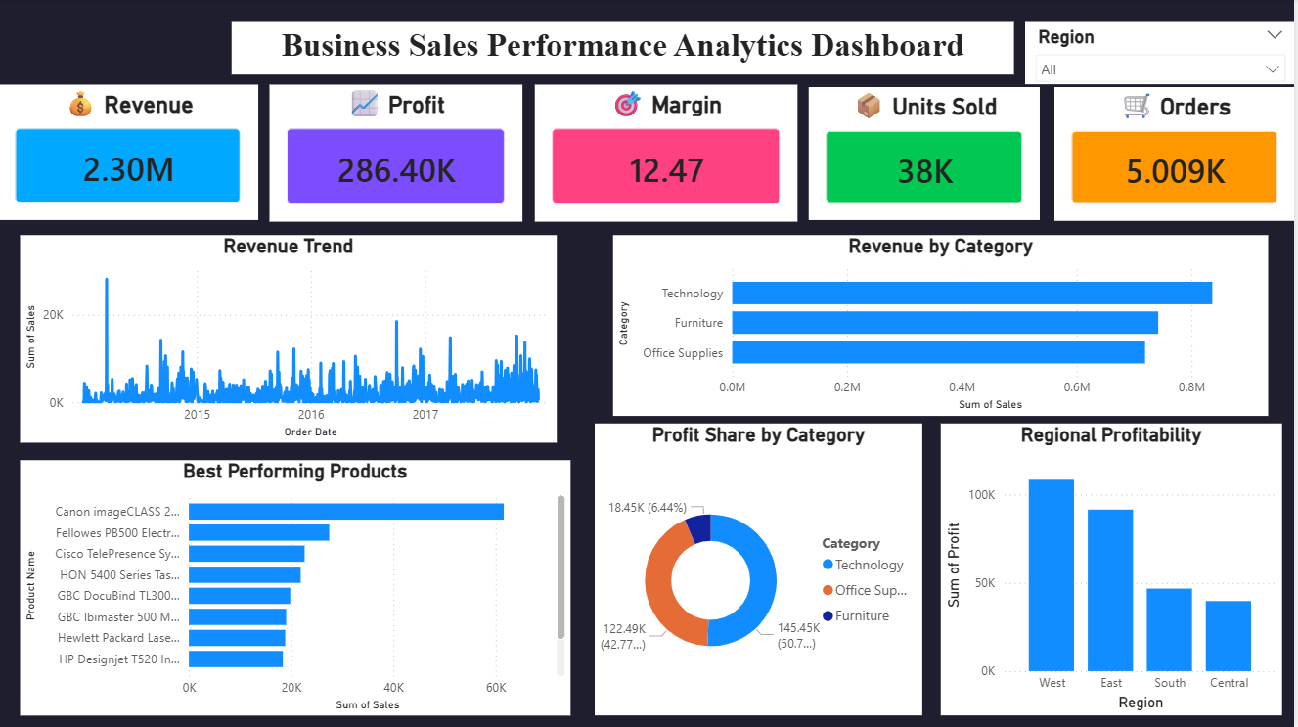
Figure 1: Business Sales Performance Analytics Dashboard

